Results file: group 21

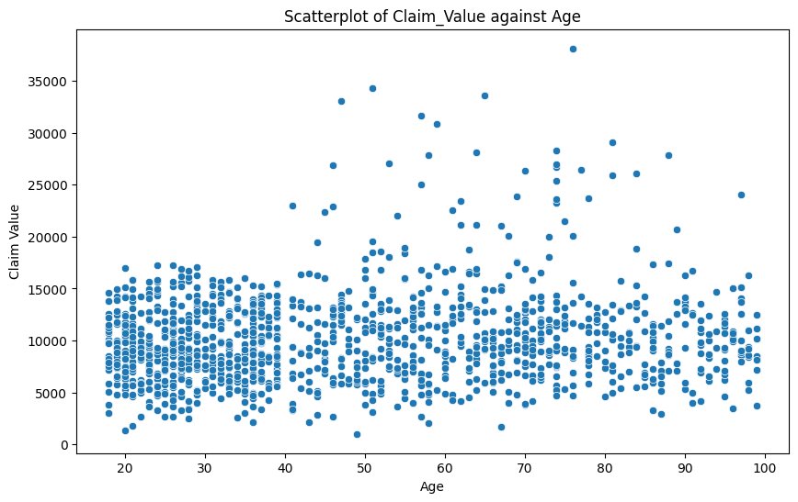
From the customers excel sheet given, the data produced two scatter graphs which are seen below:

The graph above shows the relationship between the claim value with the age of the claiming client

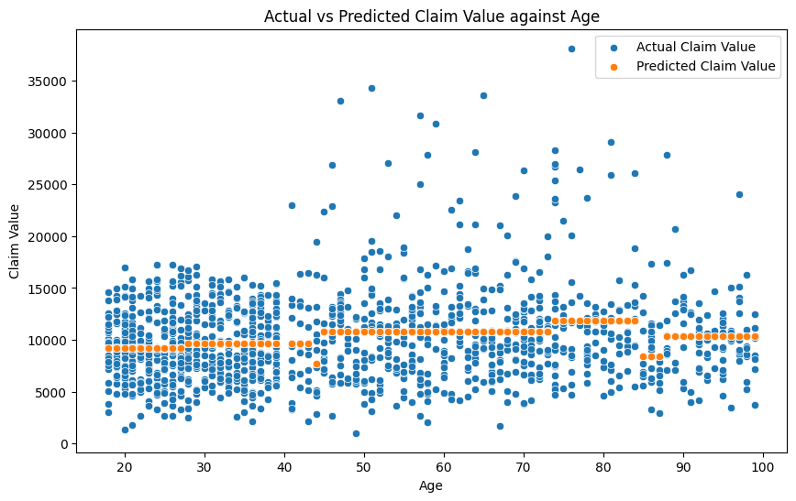

This graph above shows the relationship between the predicted claim value and the actual claim value with the age of the claiming client.

Upon analyzing the relationship between predicted and actual claim values, it becomes apparent that the predicted values tend to cluster within a narrow range, typically around £10,000 to £12,000. However, the actual claim values exhibit a much wider spread, indicating significant variability in the amounts claimed. Interestingly, despite the model's tendency to predict values within a certain range, there are notable deviations from this pattern observed in the actual claims data.
One observation is the absence of large claim values among individuals under the age of 40, particularly those exceeding £20,000. This suggests a certain degree of risk aversion among younger demographics, particularly individuals in their 20s and 30s. These individuals may be less inclined to file substantial insurance claims unless absolutely necessary, possibly due to concerns about potential repercussions such as increased premiums or financial strain.
Moreover, the distribution of claim values could also be influenced by the predominant demographic of car owners, which tends to skew towards individuals aged 40 and above. This demographic trend may contribute to the observed pattern of fewer large claims among younger age groups.
Furthermore, an odd outlier in the data is the remarkably high claim made by an individual around the age of 80, amounting to approximately £35,000. Such an outlier could be attributed to various factors, including age-related health conditions that may impair driving abilities, such as slower reaction times or diminished vision. These age-related factors could potentially increase the likelihood of accidents or incidents resulting in substantial insurance claims.
In summary, while the regression model provides insights into the general trends of claim values with age, the actual data reveals nuances and anomalies that reflect the complexities of individual behaviors, demographics, and external factors influencing insurance claims.

After conducting additional calculations to assess whether the likelihood of making a claim depended on gender, we examined the percentage of claims obtained by both men and women. The results indicated that the percentage of claims made by men and women was fairly equal, with men accounting for approximately 3% more claims than women.
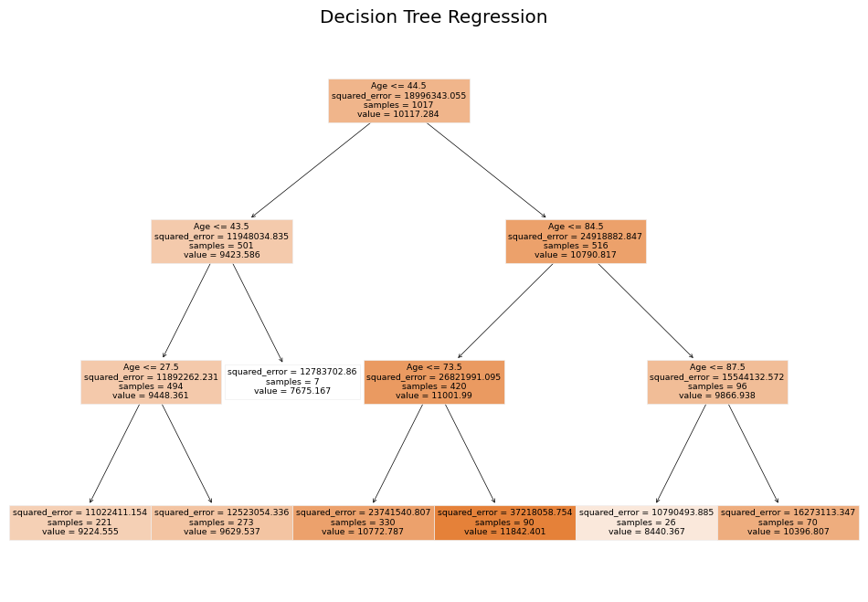
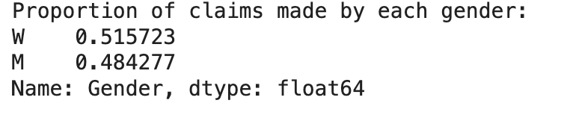
This observed difference could potentially be attributed to historical trends showing that men tend to engage in more driving activities and cover longer distances, thereby increasing the likelihood of accidents while driving.

